Boy Overboard Minecraft Project
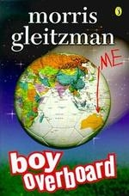
English:
EN3-2A composes, edits and presents well-structured and coherent texts
- use a range of software, including word processing programs, learning new functions as required to create texts (ACELY1707, ACELY1717)
EN3-7C thinks imaginatively, creatively, interpretively and critically about information and ideas and identifies connections between texts when responding to and composing texts
- adapt aspects of print or media texts to create new texts by thinking creatively and imaginatively about character, setting, narrative voice, dialogue and events
Science:
ST3-14BE describes systems in built environments and how social and environmental factors influence their design
- draw a plan of, or model, a built environment that includes a range of systems to meet the needs and wants of a specific group of users, eg detention centre for refugees
HSIE:
SSS3.7 describes how Australian people, systems and communities are globally interconnected and recognises global responsibilities.
- identifies human rights and how these are respected, and situations when they are not respected, in Australia and the world
Task: Students’ will be reconstructing Jamal’s and Bibi’s world collaboratively, through the identification of important places, symbols and artefacts from the text. Students’ will synthesise their knowledge by providing supporting evidence, justifying their builds, from the text. They will publish their work in the virtual space using ‘Note and Information’ blocks. They will also be publishing one of their compulsory writing activities (Novel Study activities). Buildings/artefacts/written work must be authentic and demonstrate connections with culture and novel themes.

Images of Boy Overboard Minecraft Map including text samples.

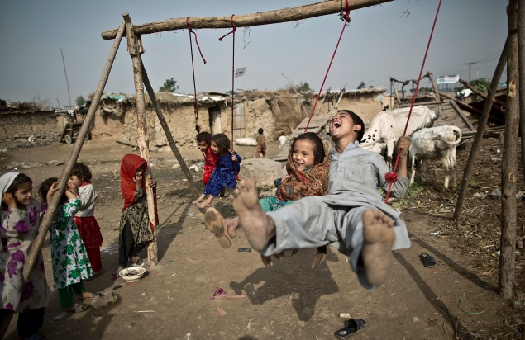
Brother and sister on swing in Afghanistan

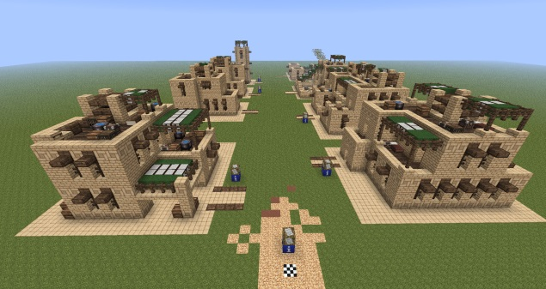
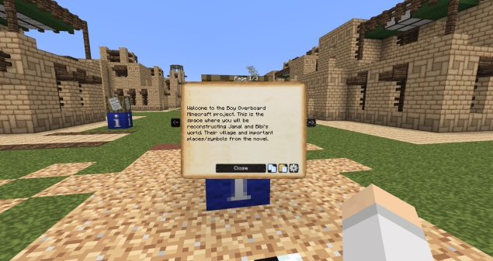

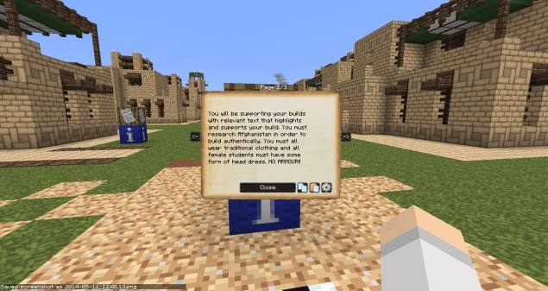
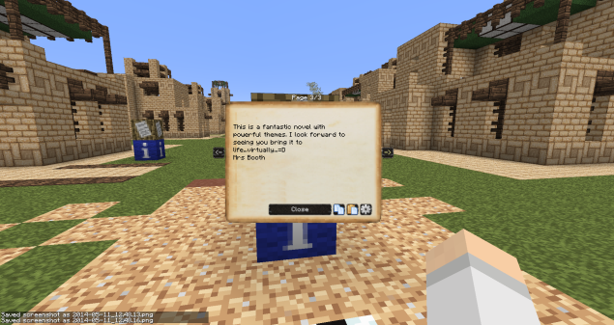

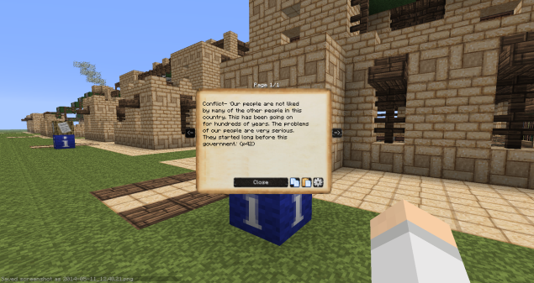
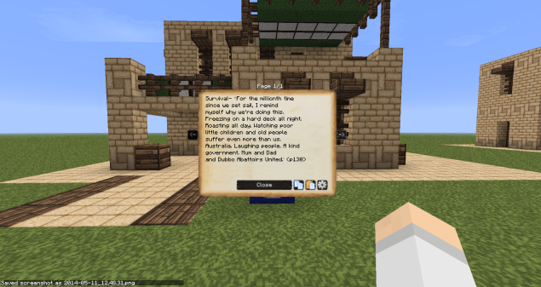

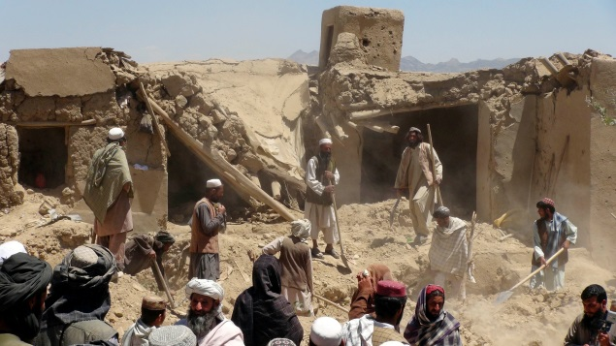
Bombing of village houses in Afghanistan
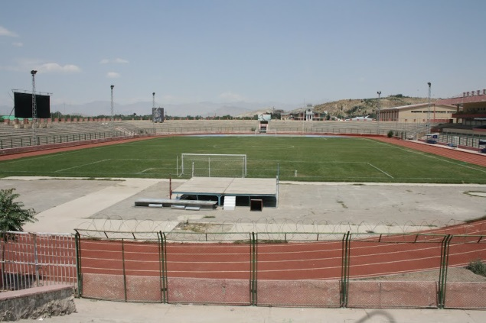
Kabul Soccer Stadium

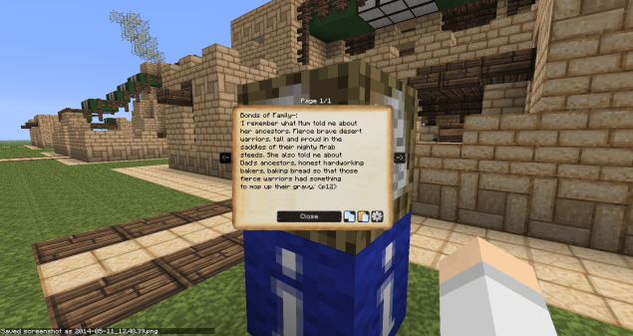

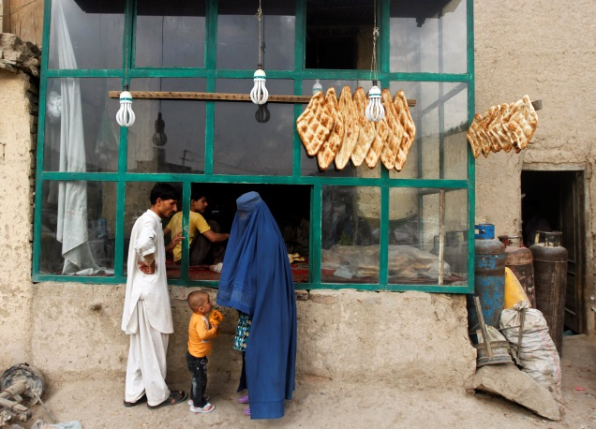
Bakery in Afghanistan
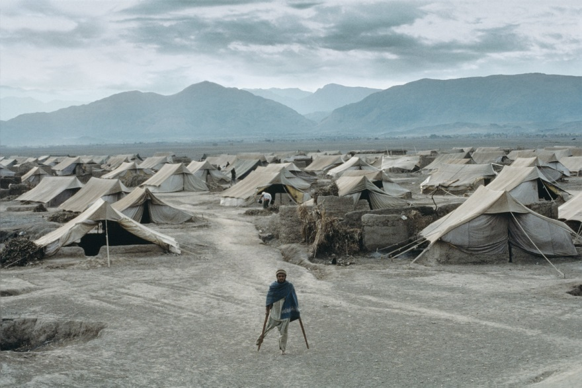
Refugee camp Pakistan
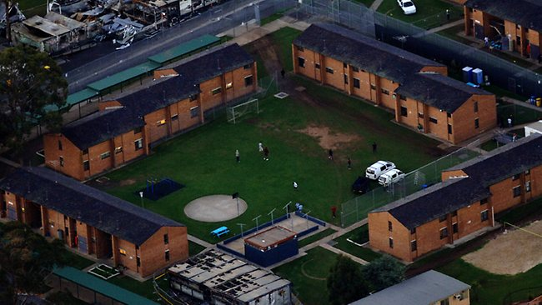
Villawood Detention Centre, Sydney, Australia

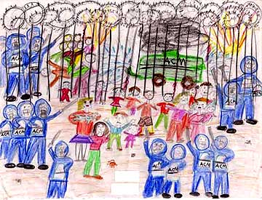
Child drawing made in Woomera Detention Centre http://www.safecom.org.au/nowayout.htm
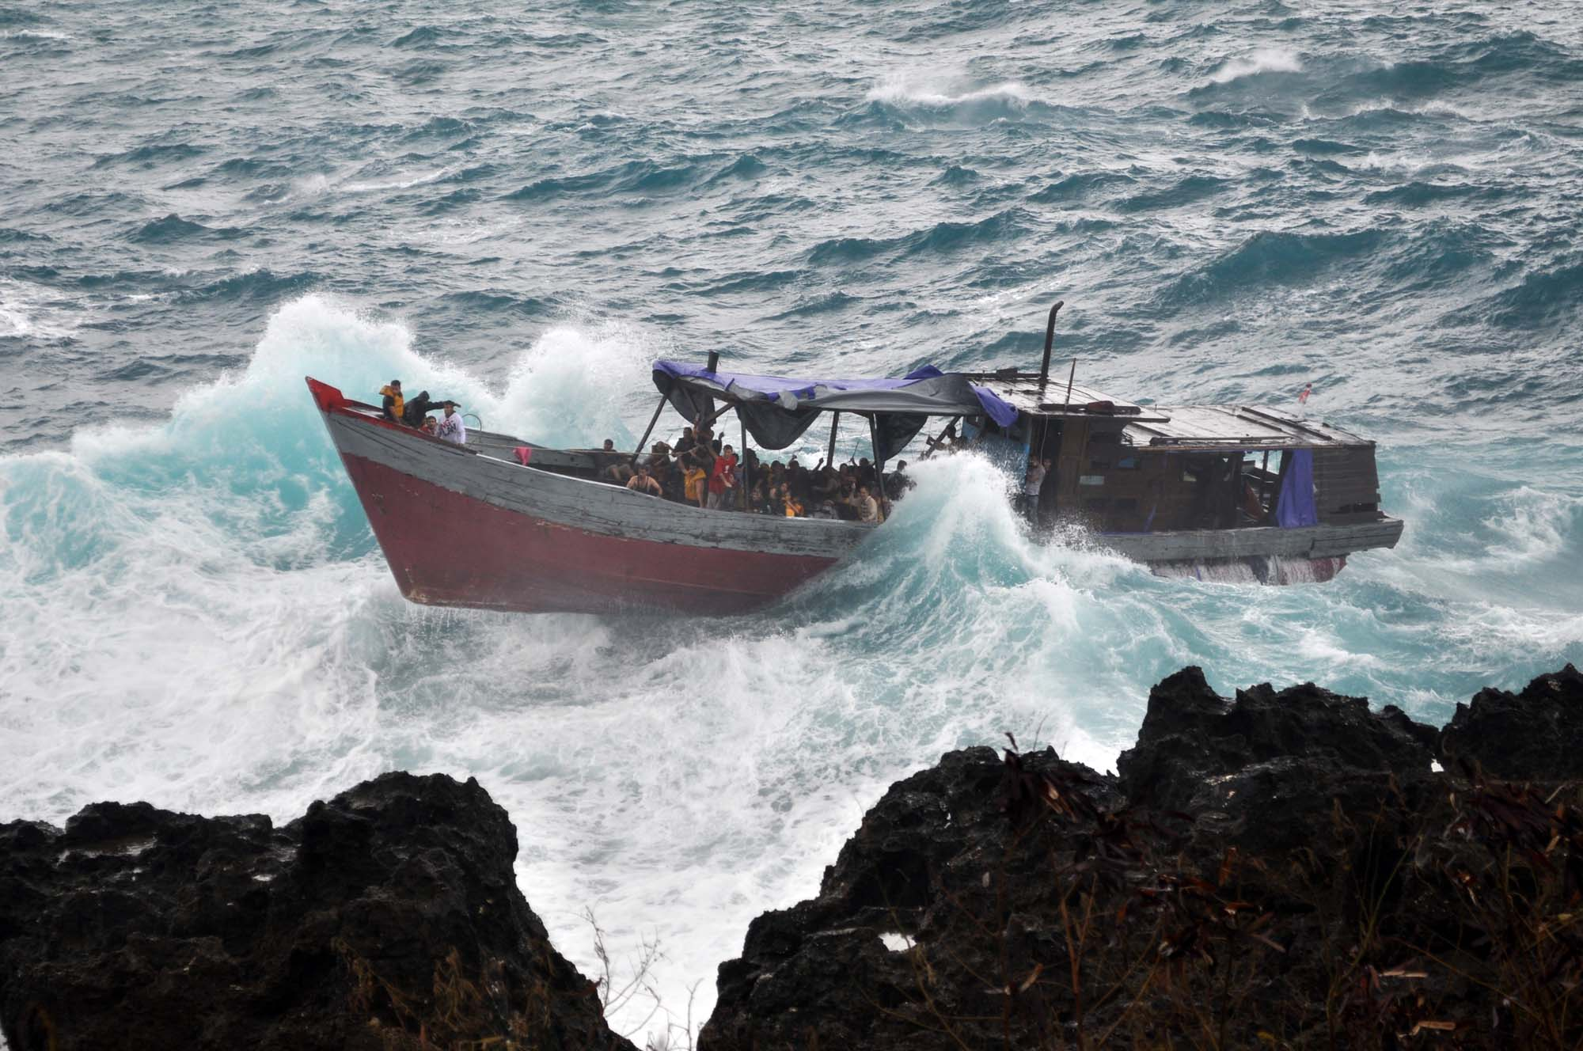
Refugees being washed upon rocks at Christmas Island
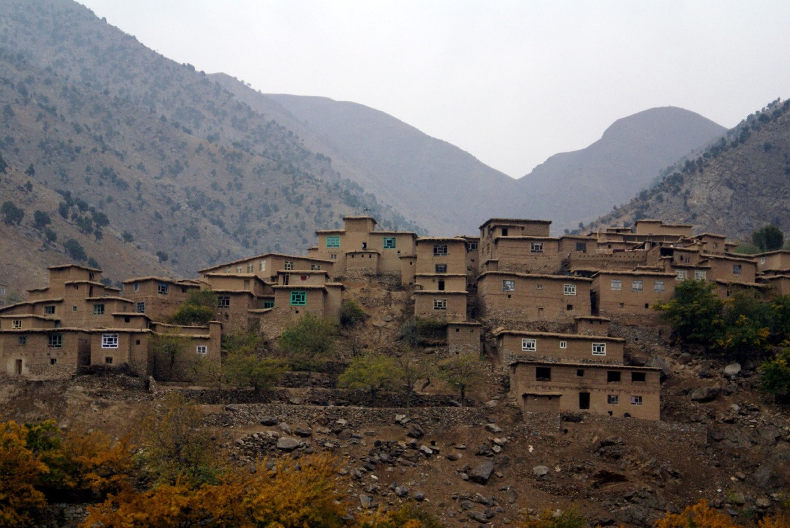
Village in the hills of Afghanistan

