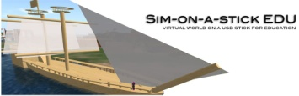
Computational Thinking Conference
PEIC 2015
Sim-on-a-Stick: A Virtual World on a USB
MinecraftEdu

Links:
- Kate Booth Examples and links: http://mrsboothsclass.weebly.com/
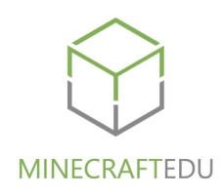
- Minecraft UnSymposium Resources: http://inevitablebetrayal.shivtr.com/pages/recordingandresources
- MinecraftEdu: http://minecraftedu.com/page/
- Minecraft Wiki: http://minecraft.gamepedia.com/Minecraft_Wiki
- Sim-on-a-Stick Edu: http://simonastickedu.com/
- SoaS Portable OpenSim: http://simonastick.com/
- Coffs Harbour Public School Virtual Building Tips/Tricks: http://coffsharbourpublicschool.edublogs.org/virtual-building-tips/
- Scratch 4 OpenSim: http://www.greenbushlabs.com/LabsBlog/?p=797
- Script Me!: http://www.3greeneggs.com/autoscript/
- Moral and Ethical Reasoning: http://www.thegoodproject.org/good-play/good-play-project/
- Digital Citizenship and the “lived curriculum” Dr Bronwyn Stuckey: http://www.netfamilynews.org/digital-citizenship-a-lived-curriculum-part-1

Contact Kate Booth - t: @SCU006 e: kate.booth@det.nsw.edu.au

